ICP1 Documentation

Webstorm Installation details:

Installed webstorm and created folder for web and mobile programming. Below is the screen shot for the same.

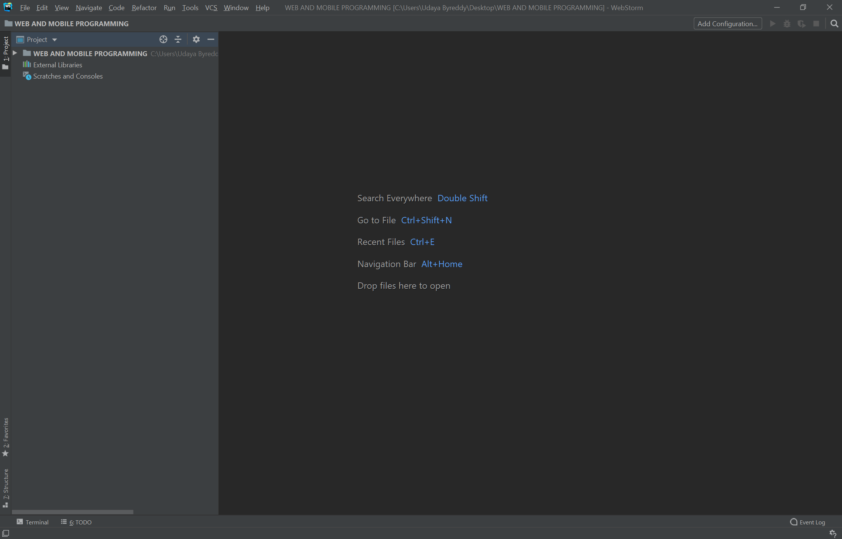

Github Installation

Created New repository in GitHub as WebMobile-2020Fall

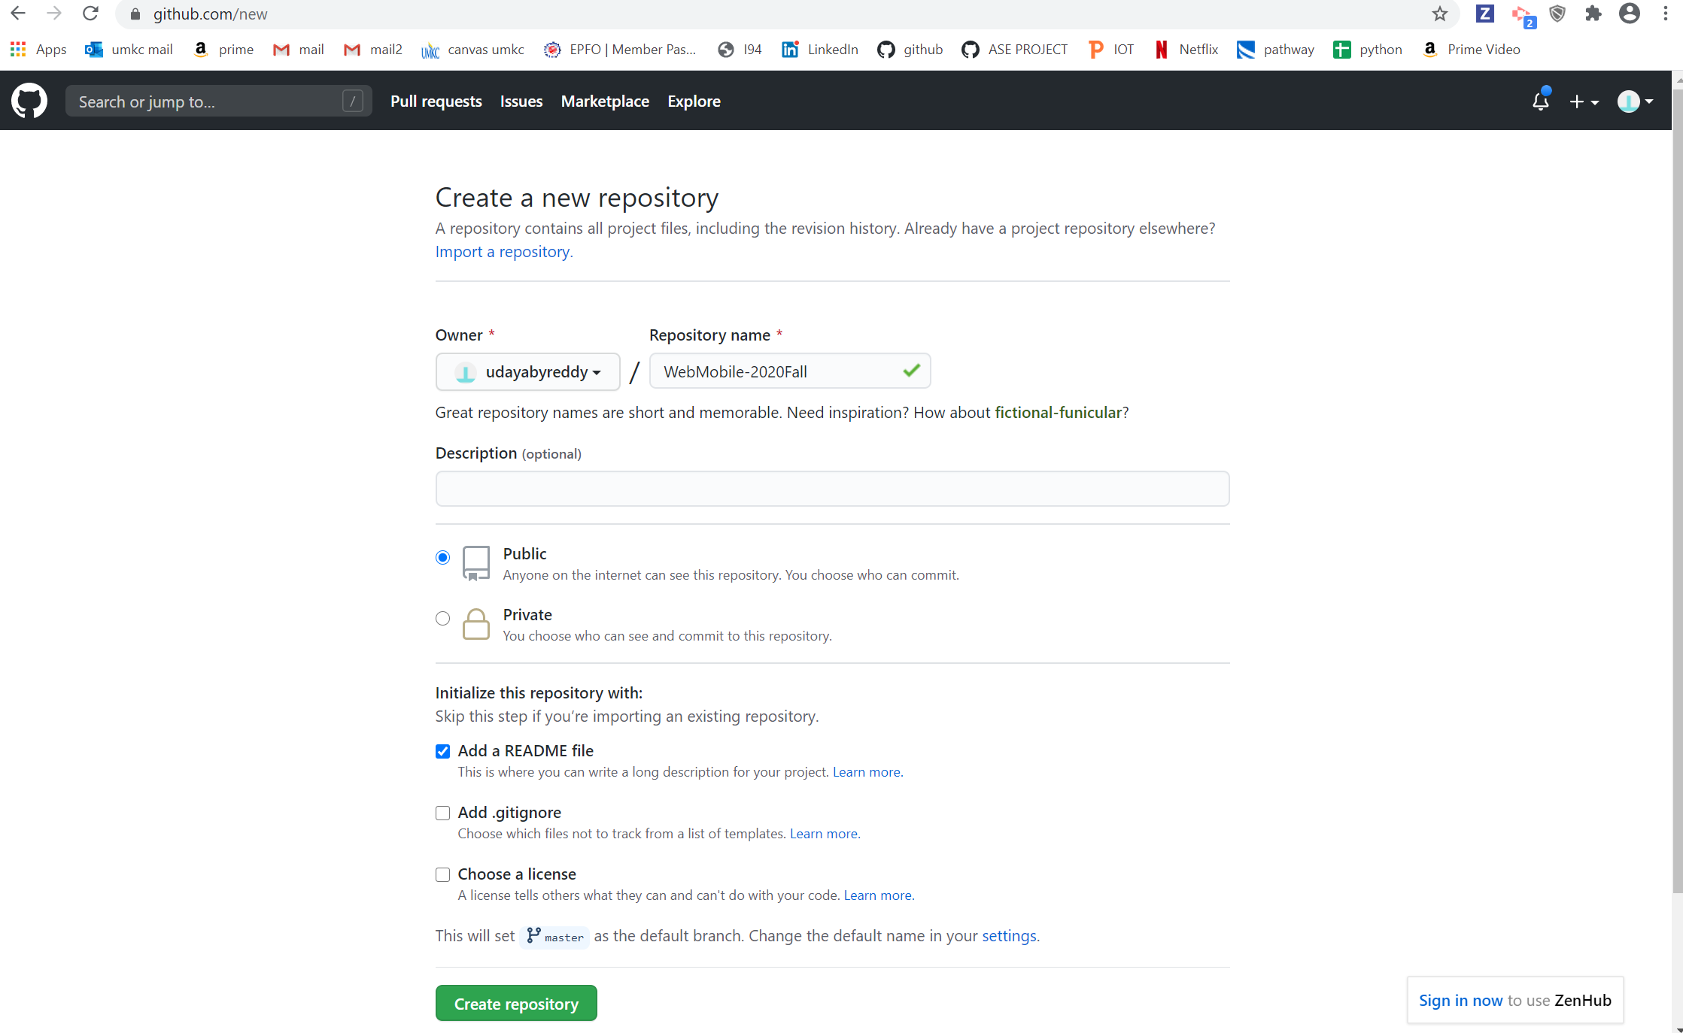

Created a readme.md file in webmobile-2020fall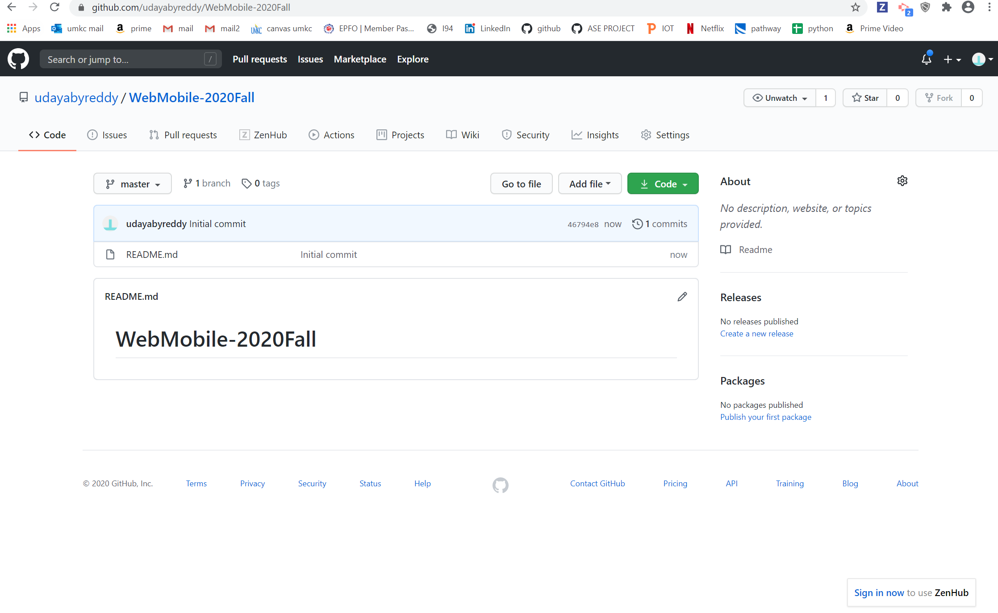

created a project named web and mobile programming then created a index.html as a sample code.

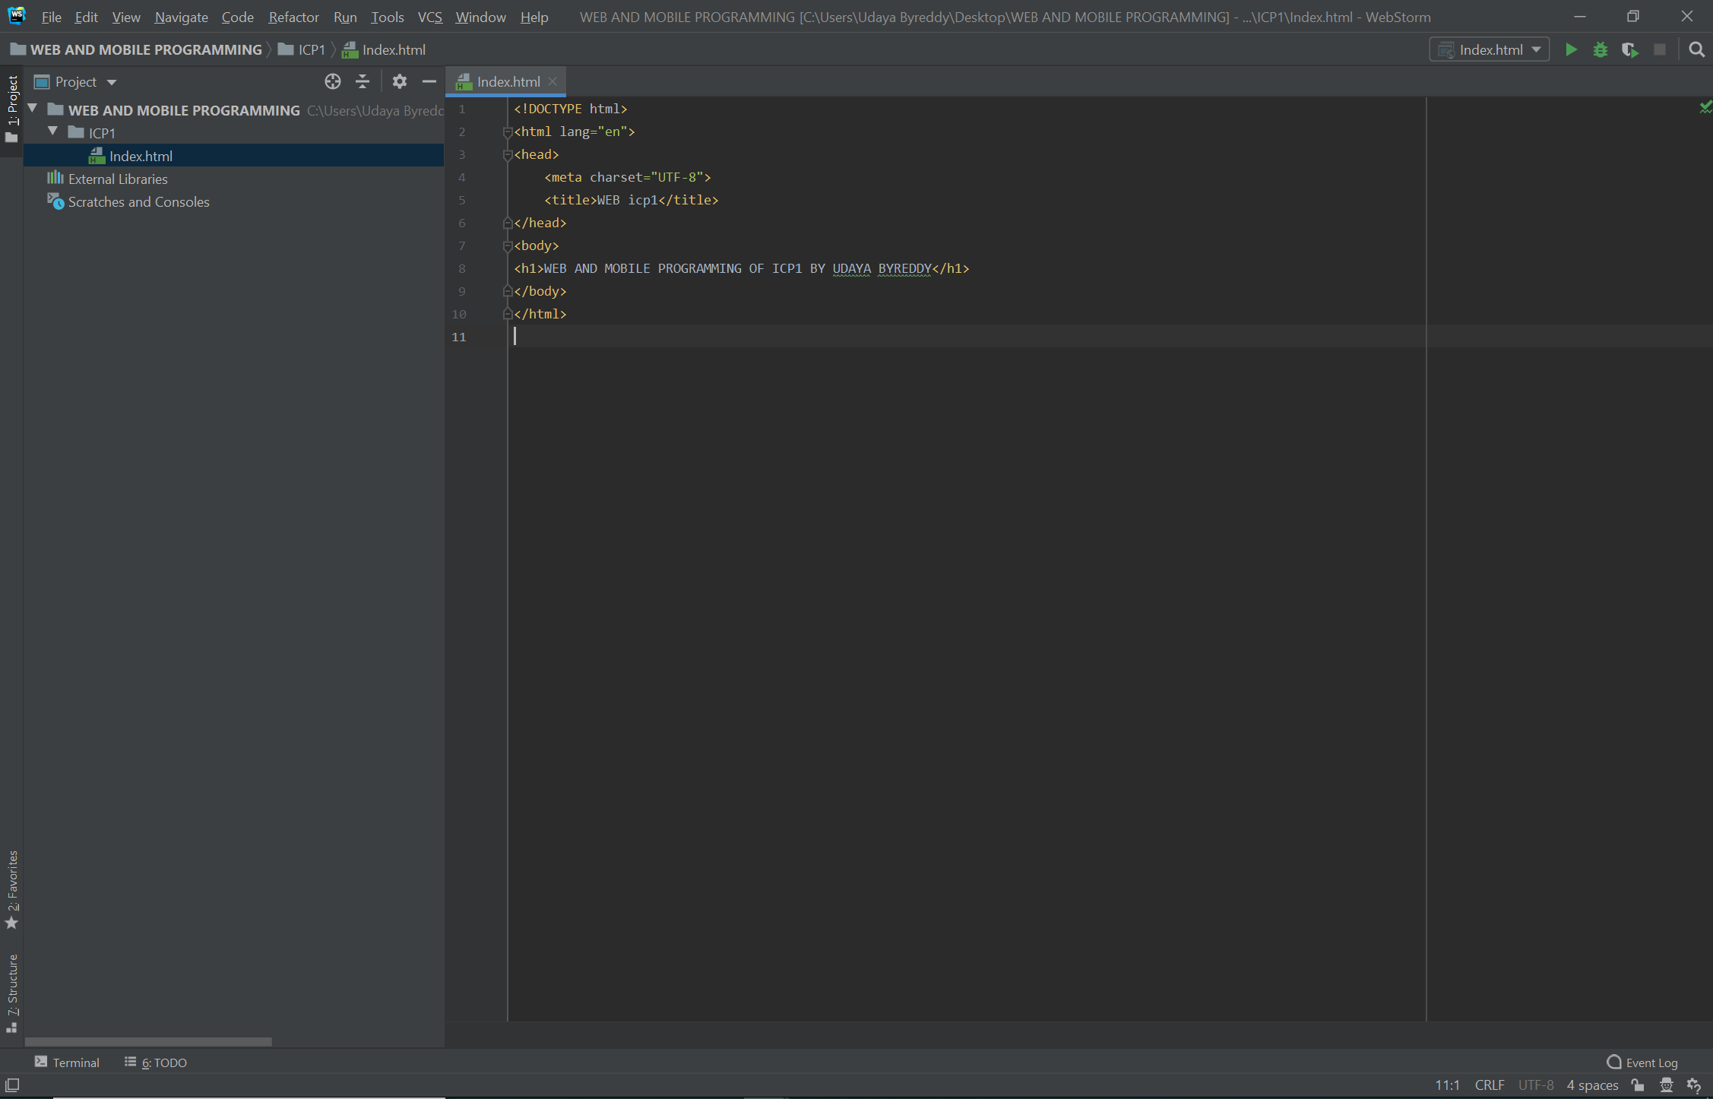

Below is the output of index.html

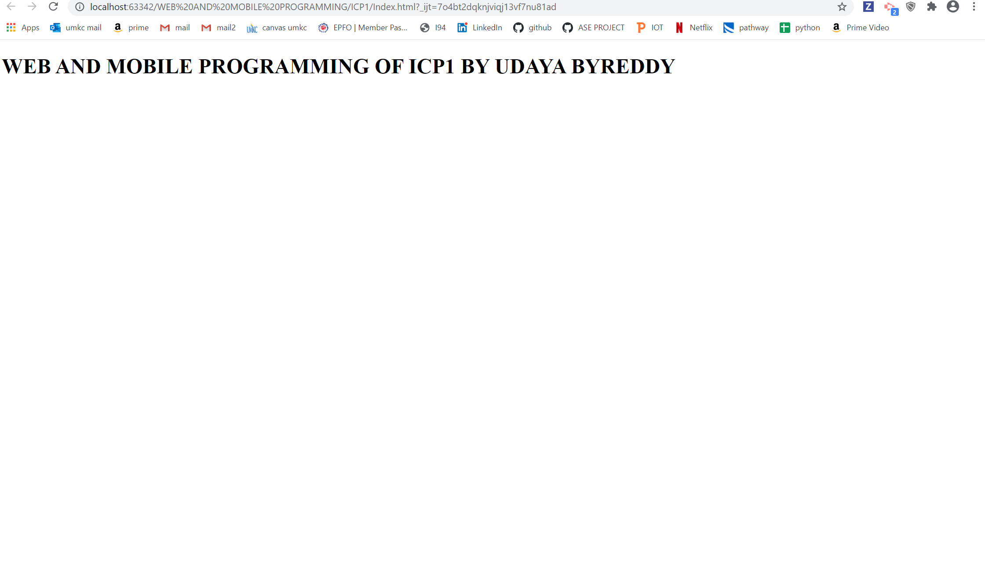

Uploaded index.html into github

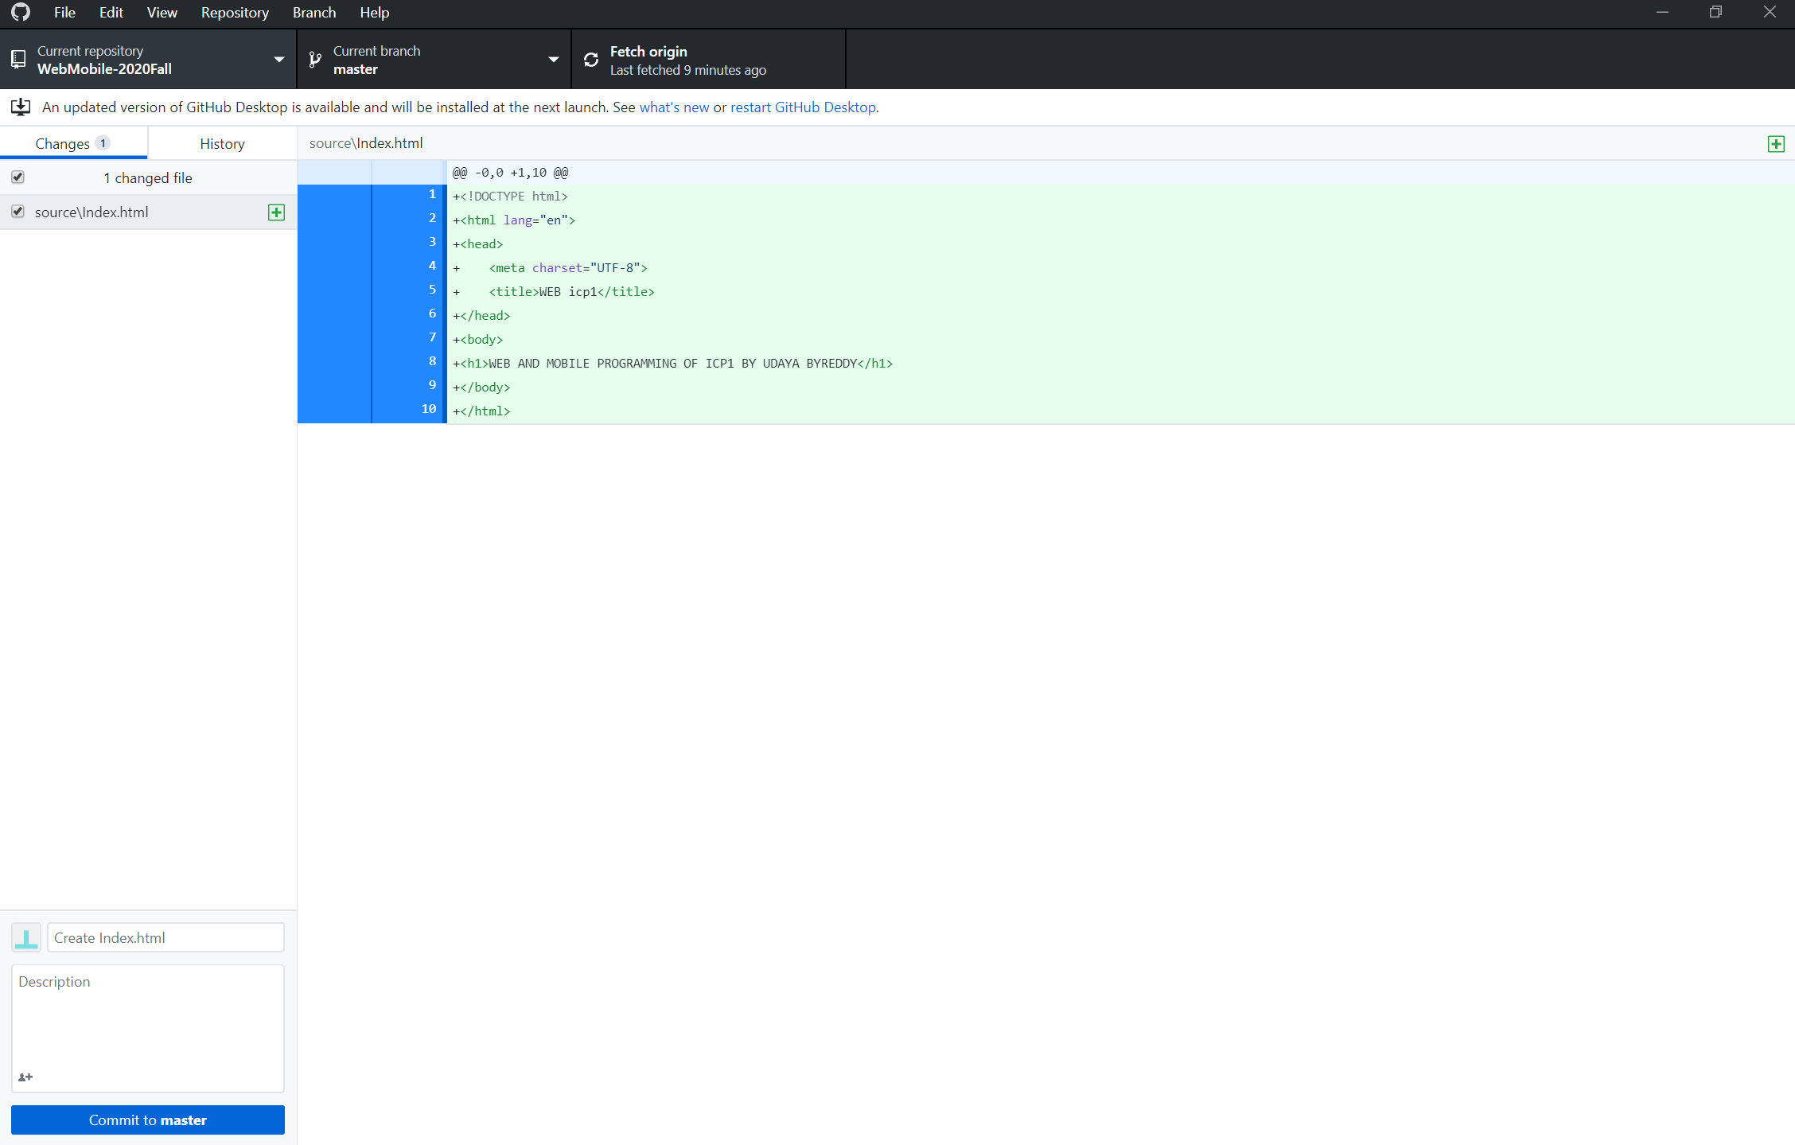

Below is the github screenshot after uploading source and documentation files and after editing readme.md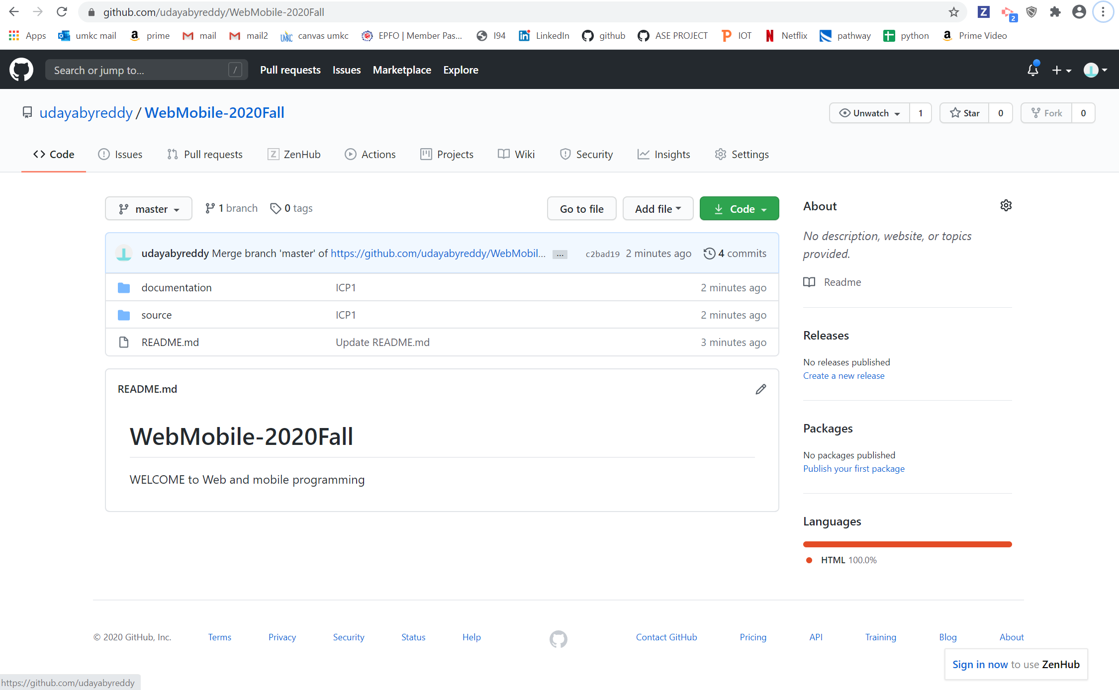

Below is the screen shot after creating branch in webmobile-2020fall

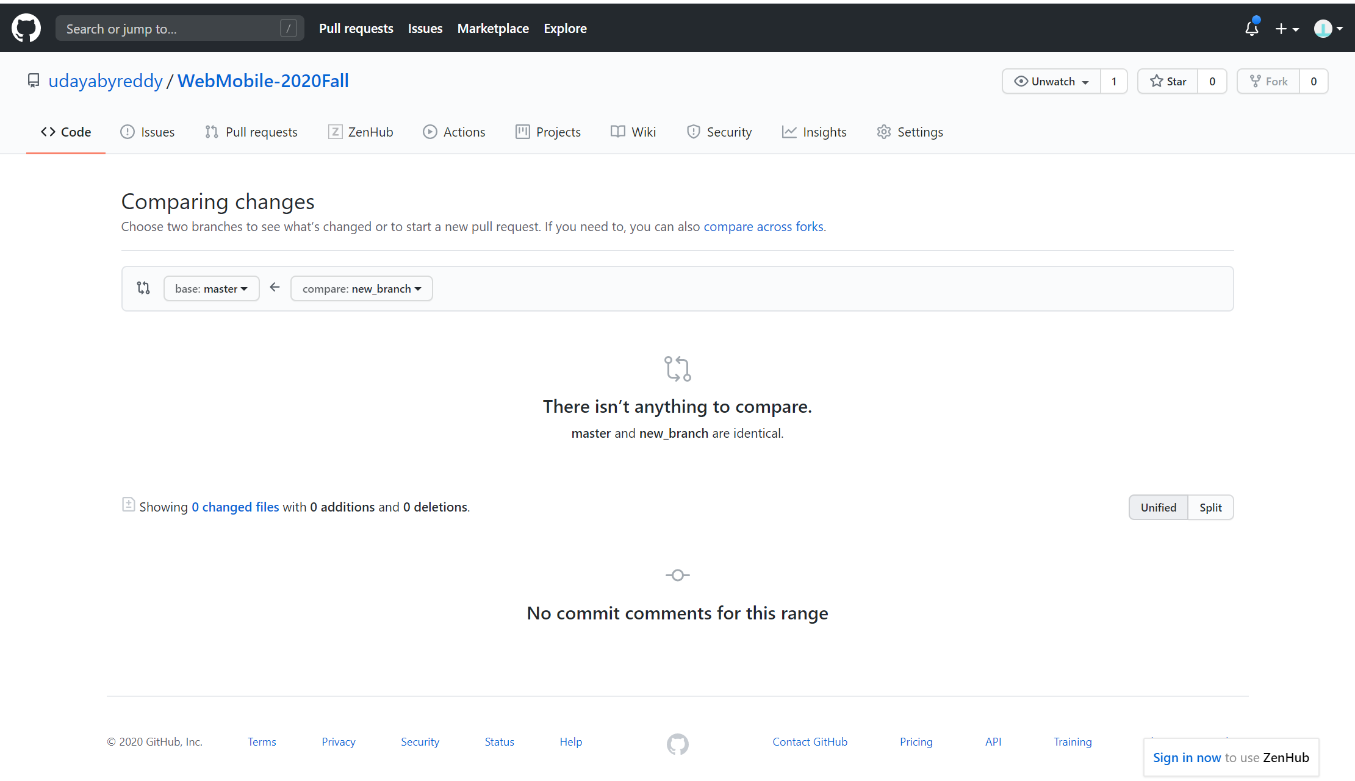

Below image shows after creating a new pull request

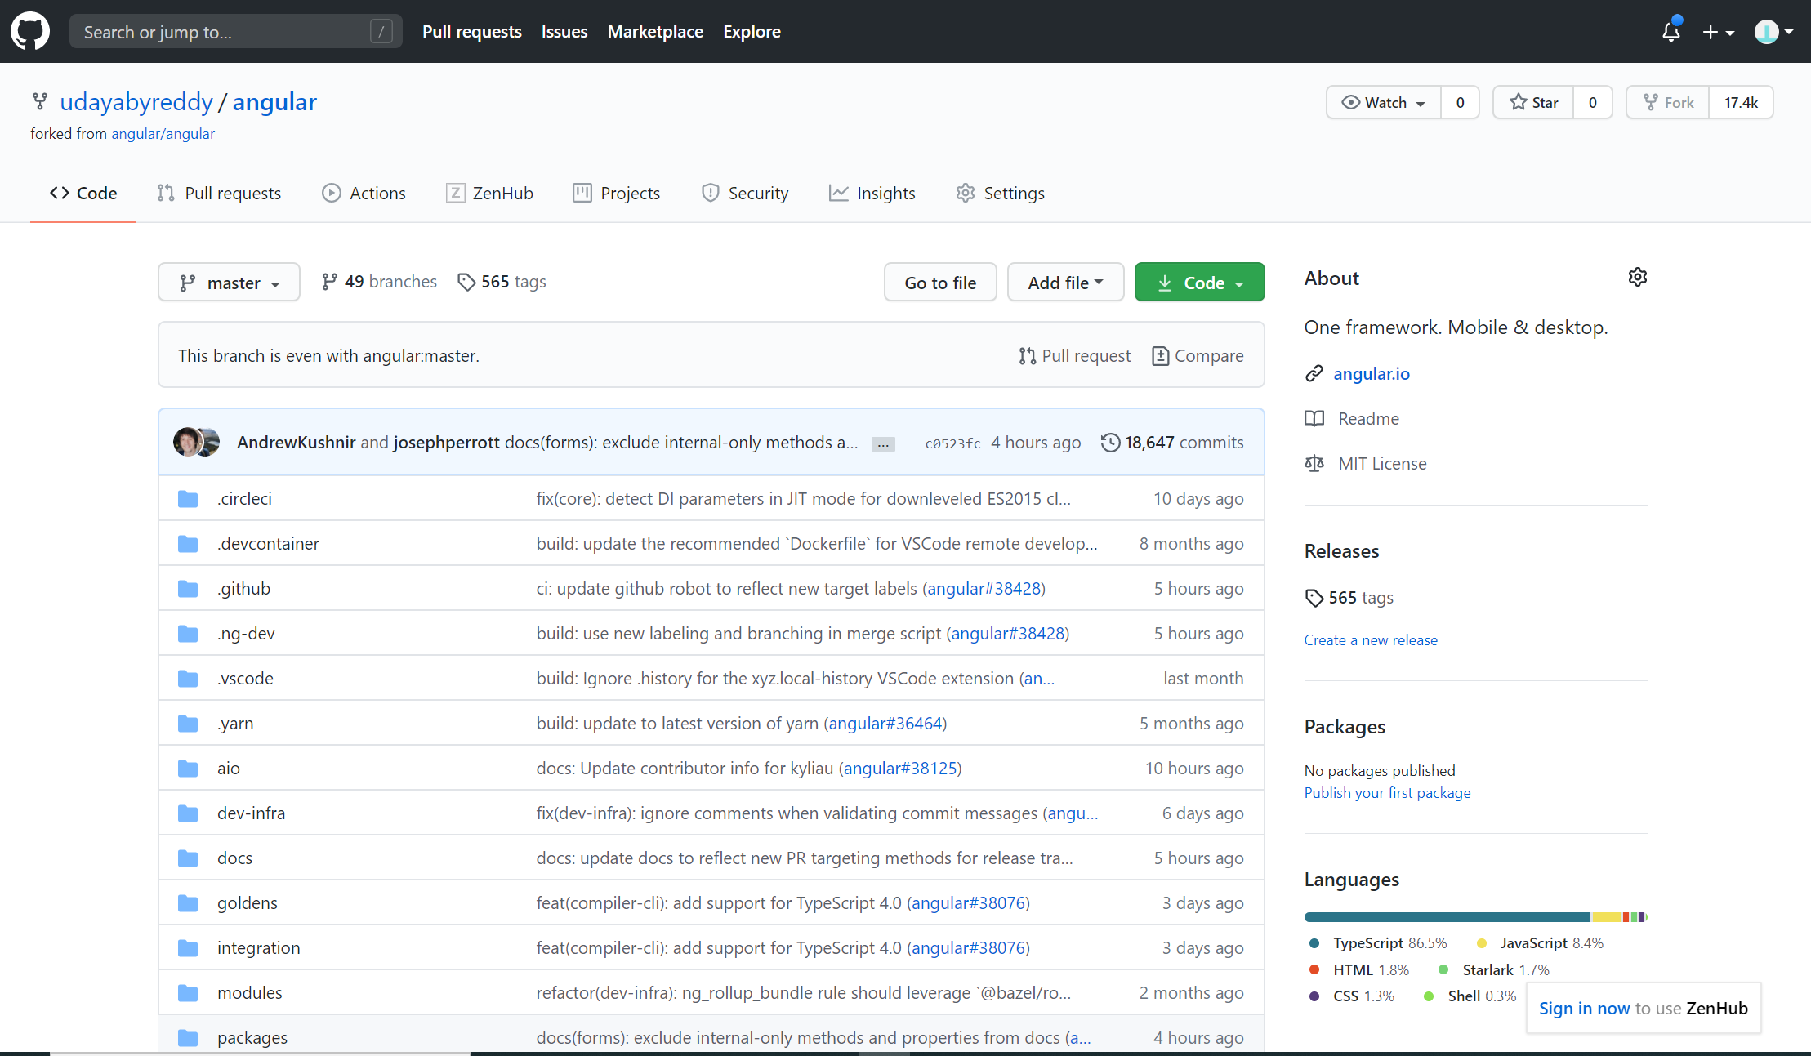

Below is the image for sample issue creation in repository

